**NAME:NAYANA J**

**USN :1BM19CS095**

**Lab 4**

**Program 2:**

**1 Create a key space by name Library**



**2.Create a column family by name Library-Info with attributes**

**Stud_Id Primary Key,**

**Counter_value of type Counter,**

**Stud_Name, Book-Name, Book-Id, Date_of_issue**

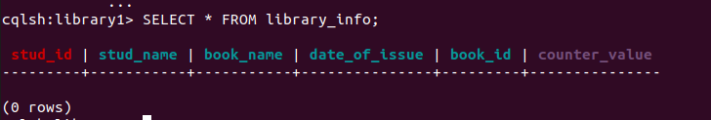



**3.Insert the values into the table in batch**

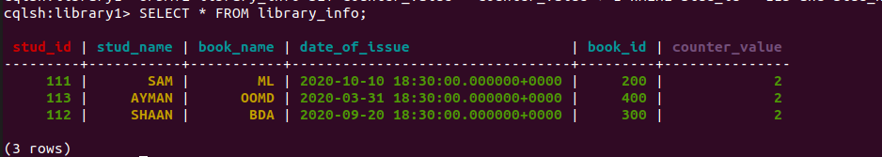

**4. Display the details of the table created and increase the value of the counter**

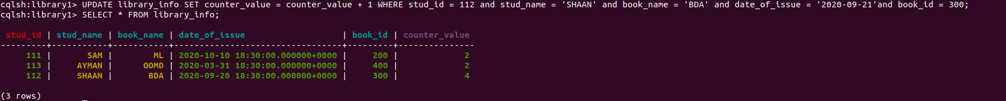

**5. Write a query to show that a student with id 113 has taken a book “OOMD” 2 times.**

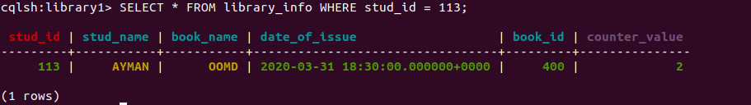

**6. Export the created column to a csv file**

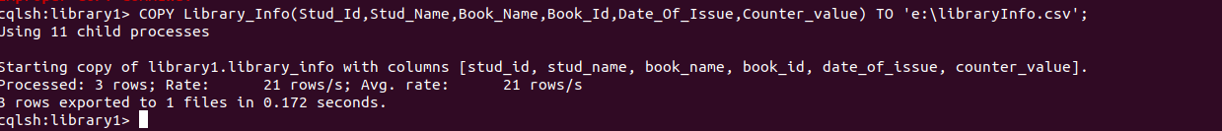

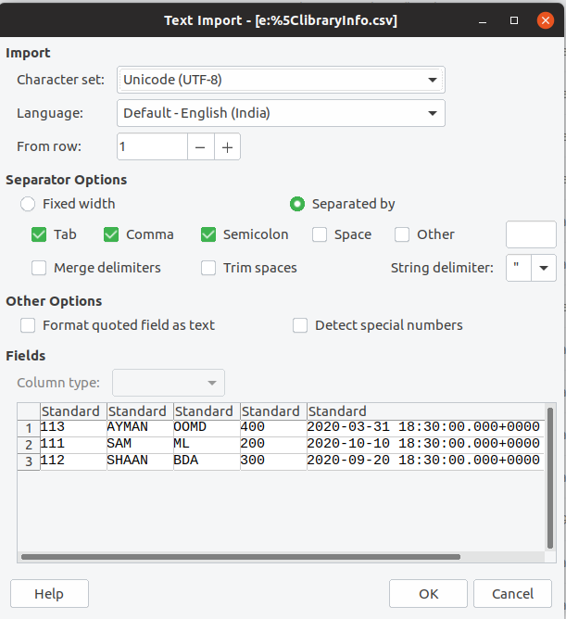

**7. Import a given csv dataset from local file system into Cassandra column**

**family**





